UNIFORM ORDER
In preparation for the winter terms coming up, we will be placing an order for our range of warm uniform items. These are optional and so we only carry a very limited number in stock. If you would like one, it will need to be ordered. They take 8-10 weeks to arrive so please place your order by FRIDAY February 28 using the google form link below. The cost will be added to your account and you will be notified when the uniforms arrive.
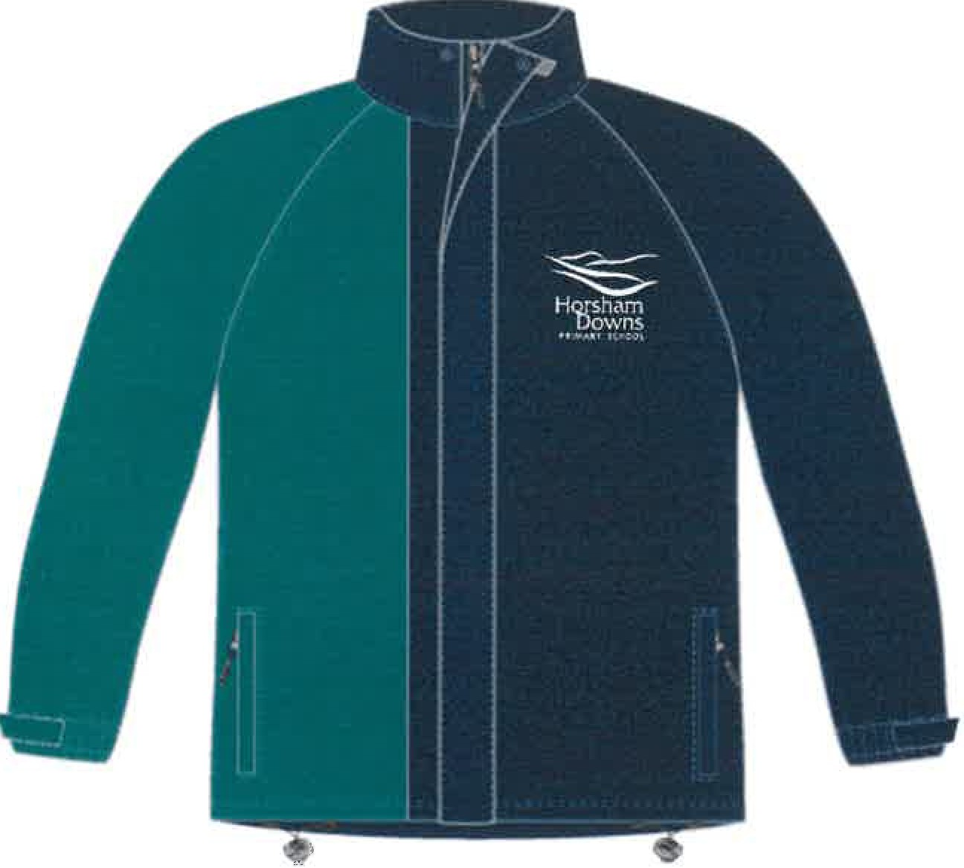
The items you may order:
SCHOOL JACKET $65

110g 100% Taslon Polyester
Full Zip with storm flap
Side Pockets with zips
Fleece lined
Shock cord hem & Velcro Cuffs
Embroidered logos

BASE LAYER FLEECE $54
220g Microfleece 100& Polyester
Stand up Full Zip
Open Cuff Hem
Embroidered Logos
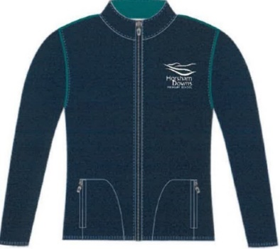

TECHNICAL HOODIE $65
***YEAR 7/8 STUDENTS ONLY
220g Cotton Sweat
Ribbed hem and cuffs
Flat piping
Logo
Mesh Lined Hood

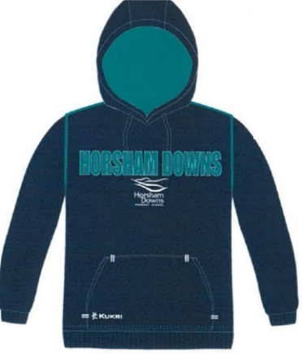

SIZING:
Size | 3-4 yrs | 5-6 yrs | 7-8 yrs | 9-10 yrs | 11-12 yrs | 13-14 yrs | XXS | XS | S | M | L
Measurement  (chest) inches | 22” | 24” | 26” | 28” | 30” | 32” | 34” | 36” | 38” | 40” | 42”

We have some items in the office if you would like to view or try for size.
Order here: https://forms.gle/M9zC6nyDUzmo6PW16

